**I think one of the biggest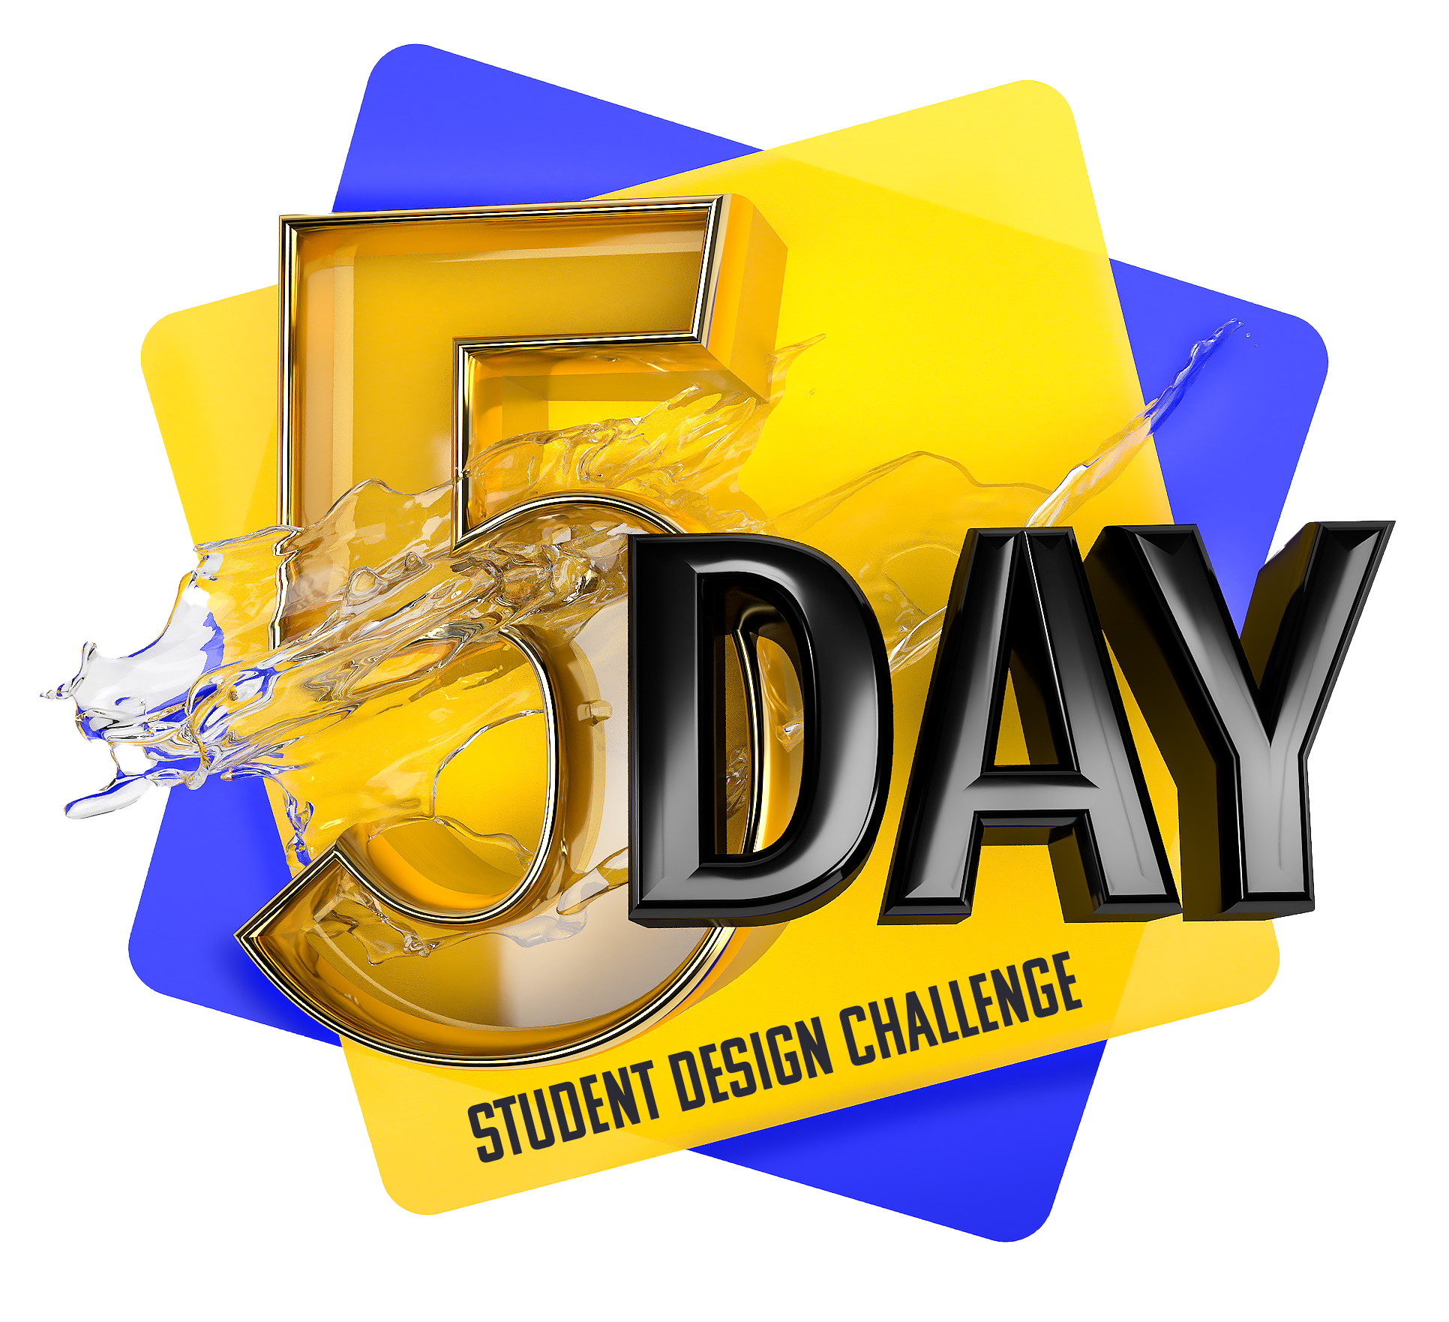 struggles for designers is having opportunities to really practice with tangible projects.**

I have created a 5 Day special challenge that anyone can tackle at any time. These projects are great ways to practice your software skills, as well as your creativity, while also adding great pieces to your portfolio.   
  
There are many different project types in Graphic Design. So, after running several student polls, I selected 5 totally different projects for you to tackle in a 5 day period.   
  
If there are one or two days where you are just not feeling creative, or just don’t want to tackle that type of design work— that is ok, do what you can. This is for fun and practice!  
  
**So, let’s get started.**

**HOW TO GET STARTED**

The 5 briefs for each project are below. There are links to examples for each day, but this is just for a bit of inspiration, not necessarily to copy exactly. **Aim to create something unique and that expresses your own personal style.**

**To submit work for each day (totally optional)** you can do any one of the following options:

**1.)** Tag me [@LindsayMarshDesign](https://www.instagram.com/lindsaymarshdesign/) on Instagram or/and use the hashtag #5daydesignchallenge

**2.)** OR you can post in the [student Facebook group](https://www.facebook.com/groups/LindsayMarshTeachesDesign) for that day.

**3.)** OR you can post in the **Q&A or community area** of the course you are currently taking if you do not have access to social media. 

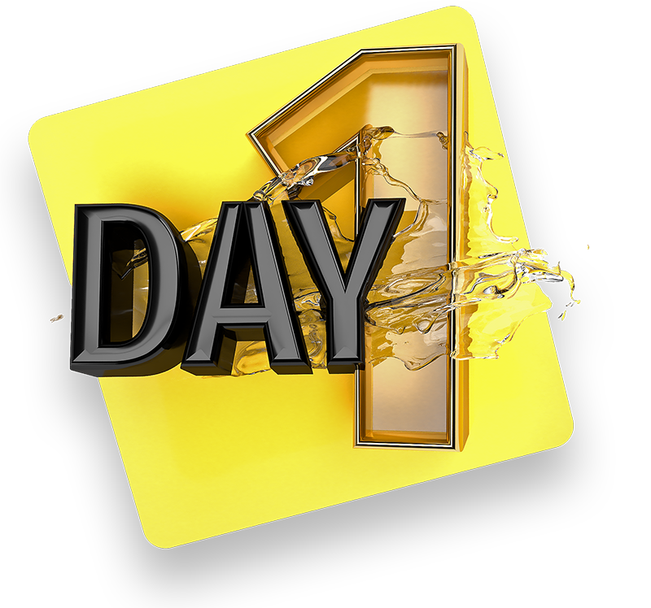

**Day 1**  
**Photoshop Composite**   
  
Photoshop composites are great ways to practice your photo editing skills. They can consist of two or more images put together to create a unique photo presentation.   
  
Your challenge for Day One is to select at least three different images from [pexels.com](http://pexels.com), [unsplash.com](http://unsplash.com), [pixabay.com](http://pixabay.com) or any other free photo site. You must use at least three images, but you can use more than three.   
  
What might help with this project is to pick a single subject to focus on. It could be an animal, a person or a place, but then choose your other photos to support that subject. These might be your background scene, clouds or something to add to your subject.

One idea could be pursuing something like Surrealism, where objects may appear oversized or undersized compared to reality. These images can have a big impact and can be a bit easier to put together as they require just a handful of images to pull off. The trick is to add shadows and highlights to the photos to make them feel like they belong together.   
  
A great example can be found here on [behance.com](http://behance.com)   
  
<https://www.behance.net/gallery/83456781/Random-Surrealism?tracking_source=search_projects_recommended%7Cphotoshop%20composite%20>

<https://www.behance.net/gallery/40820251/Composite?tracking_source=search_projects_recommended%7Cphoto%20composite%20>  
  
Another idea is putting together several photos to make more of an artwork statement piece. It usually features a main subject matter with various supporting photos around that subject that make it feel like they all belong together. A unifying theme is sometimes a color palette or the photos all come together to support a particular mood or emotion. These can be a bit harder to pull off because they can require more than three photos, but they are worth the final result as they can create something totally new and unique.   
  
<https://www.behance.net/gallery/104488231/COLORFUL-COMPOSITE-PORTRAIT?tracking_source=search_projects_recommended%7Cphotoshop%20composite%20>

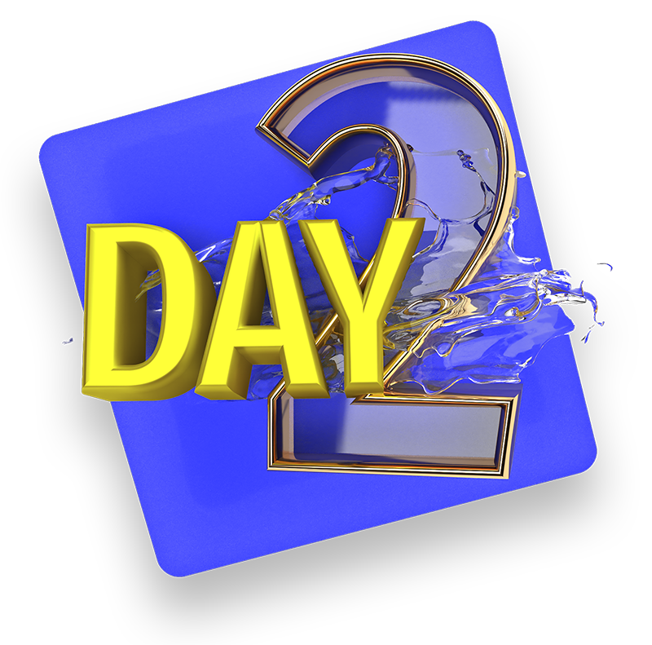

**Day 2**  
**Social Media Post**  
  
Now for Day 2: Today, I want you to put together a simple Instagram social media post using one of your favorite quotes. This can be a quote from a designer you follow, an author or someone from history. You can create a typography only layout or you can integrate photos that support your quote.   
  
I hope today’s challenge is a bit easier to manage and fun, too. Find interesting ways to play with the typography. Remember all of your typography theory knowledge, too about balance, type hierarchy and contrast to help you make a compelling post.  
  
**Some great examples can be found here:**  
<https://www.behance.net/gallery/102668169/Quotes-Collections-for-Social-Media?tracking_source=search_projects_recommended%7Cquote>

<https://www.behance.net/gallery/107523805/Social-Media-2020?tracking_source=search_projects_recommended%7Cquote%20social%20media>

If you happen to be on Instagram tag me **@lindsaymarshdesign** when you post your quote for a chance to be featured. <https://www.instagram.com/lindsaymarshdesign/>

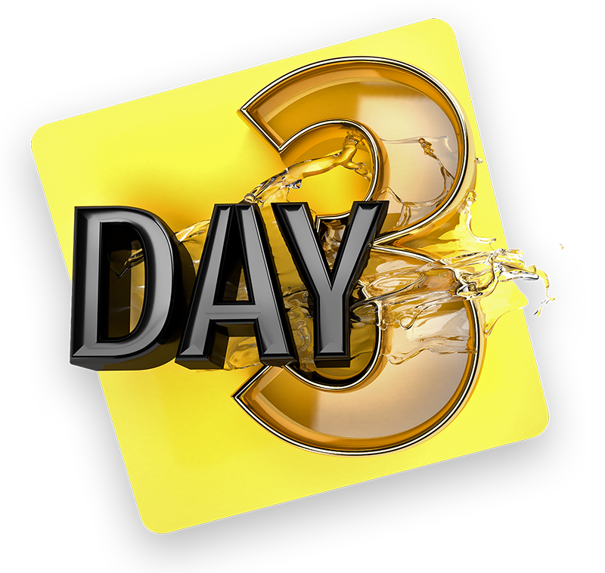

**Day 3**  
**Digital Illustration**   
  
Digital Illustration is incredibly popular these days and widely enjoyable. You have already learned the basics of vector art, so let’s put that to the test with today’s challenge.   
  
Your task will be to illustrate something in vector. You can take a portrait or photo and convert that into a vector art piece. This can take some time, so, for some of you, you might enjoy a smaller illustration project like creating a vector robot, animal or icon. Once again this can be super simple like the examples you see here.  
  
The key to today’s challenge is making it 100 percent vector. You can even take a hand sketch and vectorize that sketch into a digital graphic.

Some great examples here:

<https://www.behance.net/gallery/97506771/Character-illustrations?tracking_source=search_projects_recommended%7Cvector%20art>

<https://www.behance.net/gallery/109140425/The-Fresh-Prince?tracking_source=search_projects_recommended%7Cvector%20art>

<https://www.behance.net/gallery/109864895/Animal-Icons-Challenge?tracking_source=search_projects_recommended%7Canimal%20icons>

<https://www.behance.net/gallery/109766121/12-Colored-Fruit-Icons?tracking_source=search_projects_recommended%7Cvector%20icon>

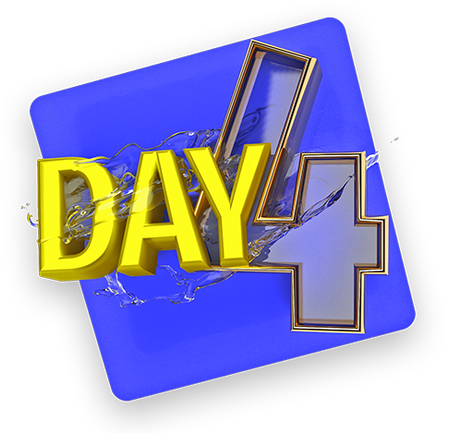

**Day 4**  
**Logo Design**  
  
Today’s challenge is a logo design for a bicycle shop that specializes in custom made mountain bicycles. The name of the company is called Bespoke Mountain Bikes . Bespoke is a word meaning customized and it also plays off the word spoke, which are at the center of a bicycle wheel.   
  
The company’s clientele is outdoor lovers who love to hike and to ride bikes down mountain trails. They are adventurous and love to take risks. They are mostly male but there are still female clients who purchase their custom bikes. They will be doing most of their advertising online through paid ads and their website. And because of this, they need the logo to look and read great in small places. They are interested in bolder typography, perhaps a sans-serif typeface.   
  
They also print the logo on their bikes and are interested in coming out with apparel like long sleeve shirts, water bottles and other accessories that a mountain bike enthusiast might need.

Here are some examples of some logos they have said are the style they are seeking:  
  
<https://www.behance.net/gallery/84190585/VRTX-Branding?tracking_source=search_projects_recommended%7Cmountain%20bike%20logo>

<https://www.behance.net/gallery/108502407/Never-Follow-Branding?tracking_source=search_projects_recommended%7Cmountain%20bike%20logo>

<https://www.behance.net/gallery/101431793/ORBEA?tracking_source=search_projects_recommended%7Cmountain%20bike%20logo>

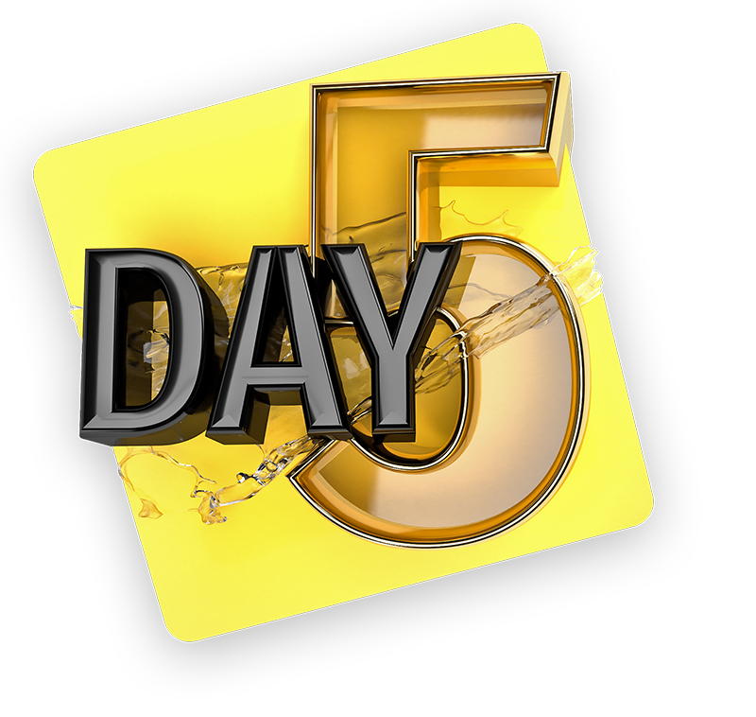

**Day 5**  
**Movie Poster**   
  
Let’s use all of our design theory and software knowledge to create a movie poster about how you feel about a recent year or the current year. I want this challenge to be more expressive of your feelings and emotions about what is going on around you.

The title of the movie poster will be a word or title that reflects your perspective on that year that also matches your chosen photo, illustration or graphics. You can use the current year but you can pick a year in the past that had a big impact on you.   
  
The key to this challenge is to express your thoughts through images, photos and in text effectively. Sometimes simple graphics work well to draw one’s eye to your design. Remember, this is all about communicating with clarity and purpose.

Movie Poster Examples:

<https://www.behance.net/gallery/109118053/SHOCK?tracking_source=search_projects_recommended%7Cmovie%20poster%202020>

<https://www.behance.net/gallery/110948707/The-Missing-movie-poster?tracking_source=search_projects_recommended%7Cmovie%20poster>

<https://www.behance.net/gallery/109246081/2021-Well-definitely-win-dont-give-up-hope?tracking_source=search_projects_recommended%7C2020%20poster%20covid>  
  
  
**Good luck and I cannot wait to see your work.**   
  
As mentioned before you can tag me on Instagram @LindsayMarshDesign at anytime during your 5 day challenge. I love to be able to share and feature student work. As always you can post your projects in the student Facebook group and in your class discussion boards. Remember, this is optional and a fun portfolio building exercise.

Instagram: [@LindsayMarshDesign](https://www.instagram.com/lindsaymarshdesign/)

Facebook: [@LindsayMarshDesign](https://www.facebook.com/LindsayMarshDesign)

YouTube: [@LindsayMarsh](https://www.youtube.com/lindsaymarsh)